Project Proposal Form
Due 1/21/2020
Limit 1 page

Project title | MIMIC III ICU Passive Sensing for Outcome Prediction
Team members | 1. Ted Hu  2. Meghan Hutch  3. Sam Hamilton

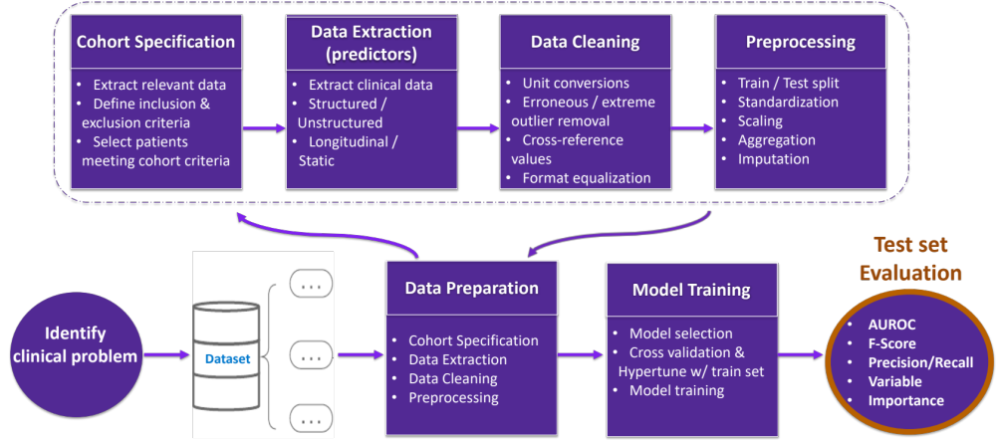
Example: Clinical Predictive Analytics Workflow (many other structures exist)
(note this for reference, you don’t need to make this)

Clinical Problem statement
- Describe the problem that your project will address.
  - By leveraging the rich time-series data taken from passive sensors on ICU patients. We hope to generate new features that might be predictive of a variety of critical clinical outcomes
- Explain the significance of the problem, and who would benefit from a solution.
  - The increased prevalence of passive data sensing tools represent a massive untapped reservoir for predictive analytics. Physicians and patients would benefit from tools that might predict if a patient is at increased risk from an outcome.

Dataset
- Briefly Describe the dataset that you’ll be using.
  - How big is it?
    - MIMIC Waveform III database has 22,317 waveform and 22,247 numeric records which have been matched and time allighned to 10,282 MIMIC-III Clinical Database records.
  - Does it contain enough training examples for your clinical problem?
    - Yes, in particular because our goal is to explore the predictive value of features.
  - Is the dataset representative of the problem?
    - Yes, as it represents an ICU population on which we would like to predict health outcomes
  - What kind of bias in the dataset can you foresee?
    - Sicker patients might be more heavily monitored.
    - Alternatively, critical or routine events might disturb monitoring

Proposed Technical Approach
- Briefly describe your proposed technical approach.
  - What are you trying to predict?
    - We are trying to predict health outcomes. We are still exploring a good outcome of interest. Perhaps something cardiac related because of all the heart sensing data.
  - What kinds of methods do you anticipate using?
    - Logistic regression, machine learning, feature extraction
  - What kinds of challenges do you anticipate?
    - Longitudinal data has unique challenges. Unbalanced and missing data are two of these. In addition, many algorithms for feature extraction may be effected by inconsistent measurement durations or missed data.
- If you’re modifying example code, reference where you got the code from.

Backup plan
If things don’t turn out the way you expect due to inadequate data, unforeseen challenges, or if you just run out of time.
- What milestones can be achieved?
  - Isolation of features from ICU waveform data
  - Evaluation of individual predictors
  - Generation of predictive model
- What is the “minimum viable product” for your project?
  - Evaluation of individual predictors
  - Isolation of features from ICU waveform data

